**English assistant in a French primary school**

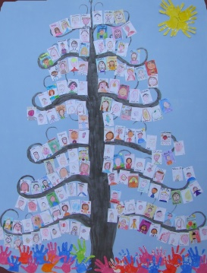**Education and/or Teacher Training**

[Ecole](http://erasmusintern.org/profile-recruiter/50864) Jeanne d’Arc de Fournes-en-Weppes

France

Fournes-en-Weppes

Period: 31 Aug, 2020 to 2 July, 2021

* Internship details

**General information**

Duration:

10 months.

Commitment:

4 days per week (Monday, Tuesday, Thursday, Friday)

Description:

We are a primary school which has 8 classes (with children aged 2 to 11) in the North of France, near Lille (17 km, 10 miles).

We are looking for a native speaker of English to assist our teachers during the 2020-2021 school year.

The school is open from 8:30 to 11:30 am and from 1:30 to 4:30 pm on Monday, Tuesday, Thursday and Friday, closed on Wednesday.

The assistant will take part in all the meetings with the staff, and decide with the teachers about the best methods of English learning.

She/he'll have:

    - to assist teacher to teach English to children (aged 2 to 11);

    - to work with teachers on projects (in Arts, or on scientific subjects); to take part of different subjects and teach them in English (scientific experience, sports…)

    - to introduce the culture of her/his country.

The school has an equipment of iPad type, laptops, interactive board.

Accommodation: the student can be welcomed gracefully in several families alternately of the school or we can help him to find an apartment to rent, at his own expense.

Compensation:

Financial compensation (around 300 euros/month) + lunch

Accommodation.

Experience required: no experience, but ideally student from the 3rd year at university. Serious and mature student.

Link: Answer to this e-mail address => [apel.jdarcfournes@gmail.com](mailto:apel.jdarcfournes@gmail.com)

School Website : [www.ecolejdarcfournes.fr](http://www.ecolejdarcfournes.fr)

**Keywords**

English assistant French primary school

**Additional Information**

Fournes-en-Weppes is located in the northern part of Nord Pas de Calais region, 15 minutes away from Lille, 1 hour away from Paris and 30 minutes away from Brussels by train, 2 hours away from London.