Illaria, intern at the Mobility Office: “Being abroad helps your curriculum to grow faster”
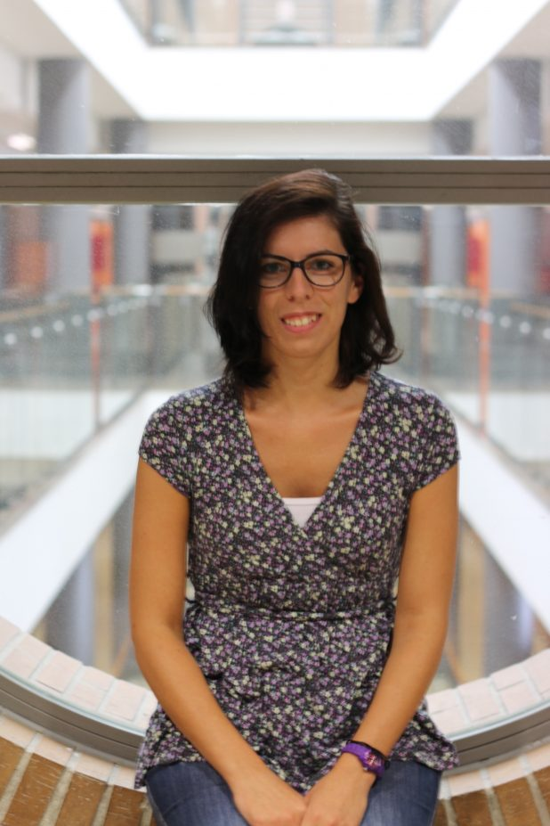
Ilaria Andreotti, came from Italy. She is from near Rovigo in the north-east of Italy. She gained her Master’s degree in European Integration Law Studies with a Bachelor’s degree in Business and Economy for Enterprises, from the Political Science Faculty of the University of Padua.
Hi, Ilaria! Why did you decide to do an internship abroad?
I have decided to do this experience firstly because I think it is becoming a professional requirement that can help me to find a stable job, then to practice my English language skills and learn a new language, Spanish, as well.
How did you find this internship offer at University CEU Cardenal Herrera?
I found it through the Italian mobility project called “Talent for neet” promoted by the association C.i.f.i.r Rovigo which helps under-30 to have a work experience in Europe.
What kind of duties and responsibilities do you have?
I worked at the Mobility Office. I was in charge of Erasmus Traineeship practices. I provided information to the students interested to do an internship in Europe following the Erasmus program, I helped them to prepare the required documents before and after the mobility.
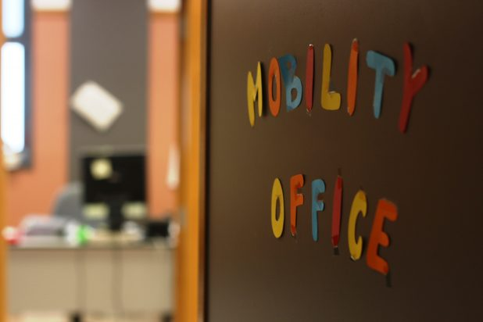Was there anything that you found challenging?
I found hard the first month because even if I could express myself in English, I was forced to learn Spanish and considering that at that point I had never studied it before, learnt it directly in the office was really hard but really exciting.
And now tell us about what has been rewarding?
What I found difficult was rewarding at the same time, that is to be able to learn a new language directly by working. Anyway, the most rewarding thing was the relationship between colleagues because they – Elena and Maria José – made me feel “at home” since the very beginning and I have never felt discriminated because of my difficulties. I will never forget them.
What about the future? Can you tell us your plans?
I’m looking for another job opportunity abroad; thanks to this amazing experience I have confirmed my recent new passion for languages.
What would you recommend to a student who is considering doing working experience in another country?
I recommend to do it without hesitations. Being abroad helps to grow professionally, because helps your curriculum to grow faster, and personally. Talking every day one or more languages opens your mind so much! As well as compare a new culture with your own culture helps to be more respectful.

