(Digital) Marketing- Internship

Unpaid 3 to 6 months full-time internship

Start date to be discussed

What is Konligo

Konligo is a start-up willing to encourage the event industry to its sustainable transition.
To do so, Konligo creates innovative, reusable and fancy pop-up structures, made in Belgium and with recycled aluminium.

These structures present several advantages. First, the set-up time is reduced from days to minutes dependant of the size. Then, the qualitive structures have a large life span, encouraging multi- and reuse. Last but not least, the design of the structures is unprecedented and can be customized easily with a fixed frame but altering visuals and decorations. Check it out for yourself in this video.

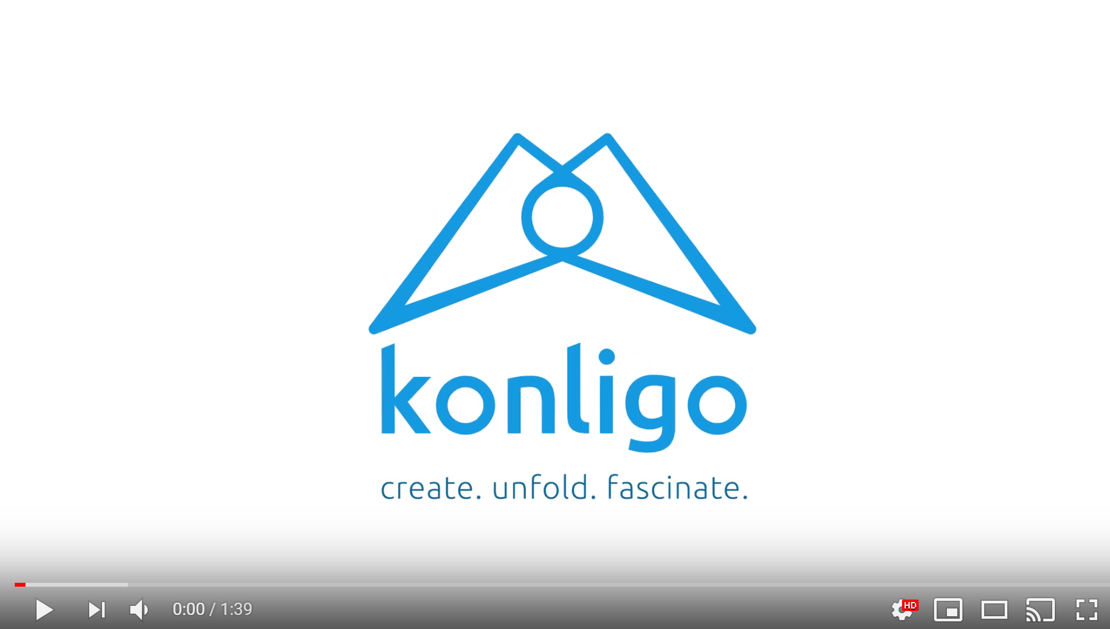

Today we are a small passionate group of people and eager to let an enthusiastic person join our team, helping us in making Konligo become the leader in sustainable stand and pop-up structures.

If you like the project, then keep on reading.

What is the job about
Since we are a start-up and you will be joining a small team there is always a lot to do !
However your main tasks will be:

- community management (Facebook, Twitter, Instagram…)
- develop creative content and/or draft articles
- develop press contacts
- website updating (wordpress) & SEO
- prospection (mail-phone-linkedin)
- event management (internal or external)

What we look for
It is always better to come to the office and see your colleagues smiling !
So we look for someone optimistic but also :

- motivated and curious
- with good English (writing and reading) level
- well organized and flexible
- Experience with Wordpress is a pro.
- creative with communication skills

What we offer
- A truly professional experience in a small easy-going team in Brussels.
- An ambitious project with lots of opportunities
- A stimulating environment (start-up and event industry) and a rewarding position with immediate impact for the company development.

A minimum of 3 months internship.

How to apply

If you want to be part of the project and change the world of event industry with us, send us a cover letter and explain us your motivation. Feel free to express your creativity!
We will be very happy to meet you and maybe enrol you in our team !
Contact person : simon@konligo.com
For more info about our company have a look at our website : www.konligo.com and follow us on social media ;)

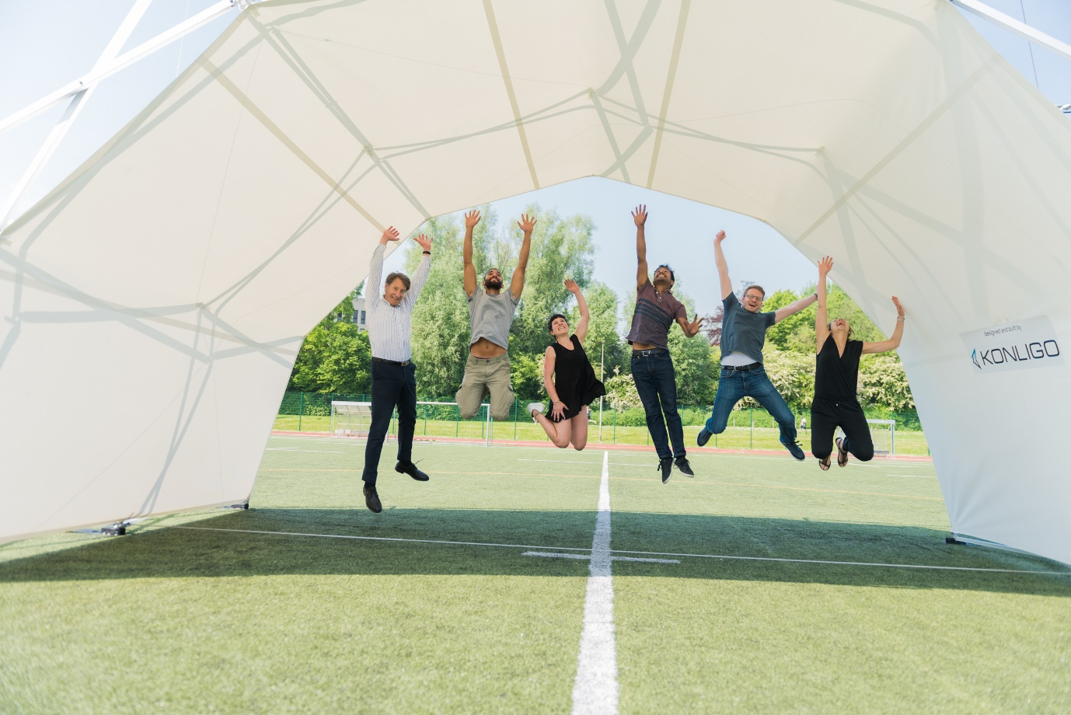

FROM KONLIGO WITH LOVE

